Hello Parents,

We are excited to offer an amazing new optional performance opportunity this season for Angie’s Starz Dance Team!!

We will be performing with Dance The World Disney June 20th-24th, 2022 at Walt Disney World in Orlando, Florida.

Our students ages 10 & up will perform in a parade in Magic Kingdom Park (Dance the World Disney provides choreography and costumes.)

Our students ages 7 - 9 will perform in the Celebration of Dance Showstopper at the Walt Disney World Resort (Dance the World Disney provides choreography and costumes.)

Our students ALL ages will perform together in the Stage Show Performance inside the Walt Disney Resort (Angie’s Studio choreography and costumes.) Rehearsal schedule and costume details TBA.

All Angie’s Starz families will be required to stay at the Disney’s All Star Movies Resort.
https://disneyworld.disney.go.com/resorts/all-star-movies-resort/
4 day resort and 4 day Park Hopper tickets are included in your package. Please see the attached flyer for details, pricing information and a sample schedule. Please note, the reservation link is included in the flyer. Families will register directly through the link with Dance the World Disney. (Not through Angie’s Studio) There are several customizable options for families to create their perfect trip. Please read over the information carefully, including their cancelation policy.

Fees to be paid directly to Dance the World Disney (Not through Angie’s Studio)

First deposit: $295.00 per person (not per family) due at the time of booking; book by October 25th, 2021

Second deposit: $200.00 per person (not per family) due December 1st, 2021

Final balance: Due February 1st, 2022

We have set up a Zoom meeting with their Director next Sunday, September 19th at 6:00 PM to answer any questions/concerns you may have. Click the following link to attend;

Join Zoom Meeting
https://us02web.zoom.us/j/86377856520

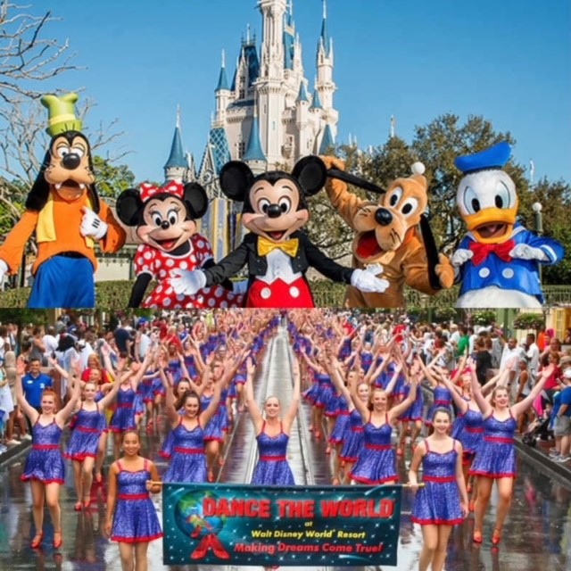

Attached is a copy of the Zoom meeting regarding the Disney event for anyone unable to attend or looking for additional information.:) Link will be available till Oct 20, 2021

Click to Download

Angie's Studio Parent Meeting Recording.mp4
206.8 MB

If you have issues opening the above link you can try the drop box link provided below.

Link: https://www.dropbox.com/s/f5wi7zs6fs8h0an/Angie%27s%20Studio%20Parent%20Meeting%20Recording.mp4?dl=0

If you have any additional questions, please contact Dance The World Director Andrew Stine - 610-477-7340 - andrew@wcv.com

