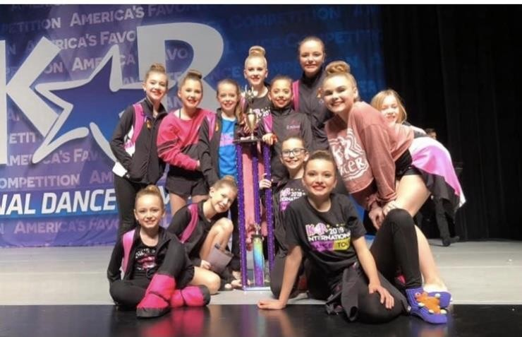
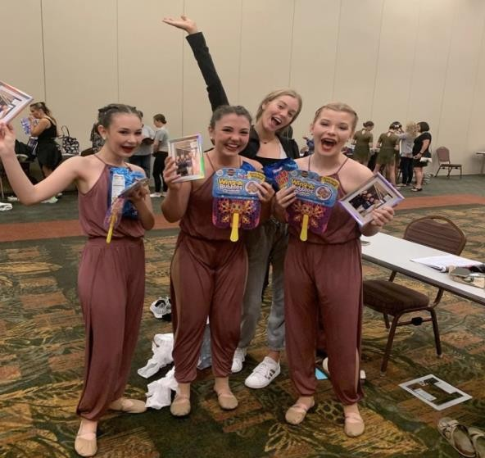
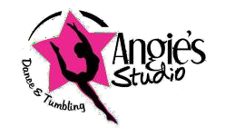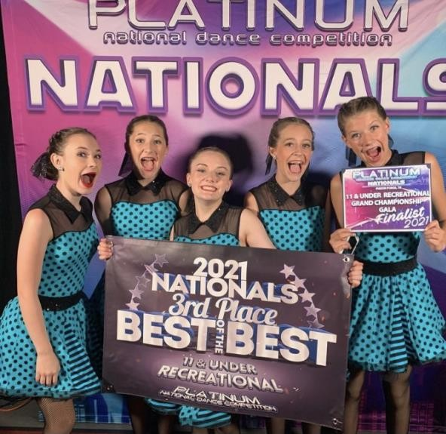

ANGIE’S STARZ DANCE TEAM AUDITIONS
SUNDAY, AUGUST 29TH 2021
Angie’s Studio 300 E Pearce Blvd.
Wentzville, MO 63385

AUDITION TIMES
(Students must have had no less than 1 full year of dance training and be between the ages of 5-18)
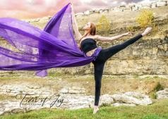

1:15-1:45 PM
Parent Informational Meeting

2:00-2:45 PM
Ages 5+ (Pre-Dance, Pre-Combo, Combo I, Combo II)

2:45-3:30 PM
(Combo III & Combo IV)

3:30-4:15 PM
(Combo IV/V & Combo V)

4:15-5:00 PM
(Juniors)

5:00-5:45 PM
(Senior A & Senior B)

IF YOU ARE UNABLE TO ATTEND AUDITIONS, PLEASE LET MS. ANDREA KNOW VIA TEXT OR E-MAIL PRIOR
TO THE AUDITION DATE. 636/ 578-3579 stcbelieverfever@aol.com

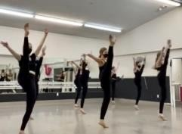

AUDITION DRESS CODE

- Solid colored leotard or sports bra (any color) with solid colored booty shorts (Black preferred) and Tan tights. (Junior & Senior level students wear Black ankle length leggings)
- Hair secured in low bun
- Bring proper shoes for whichever subjects you're auditioning. (Tap, Jazz, Lyrical, Hip-Hop, etc.)
- Arrive 10 minutes early to check-in, receive your # and stretch.

DANCE TEAM INVITATIONS

- Dance Team Invitations will be sent out via e-mail by midnight on Wednesday, September 1st.
- Dance Team Invitations must be accepted and returned via e-mail to the following address, no later than Friday,
September 3rd. stcbelieverfever@aol.com
- Mandatory weekly Team rehearsals will begin Sunday, September 12th. The rehearsal schedule will be included in your invitation.
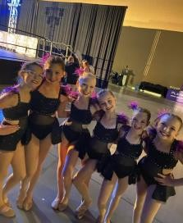

Dance Team Tuition

- Tuition: $198 total per each group dance competed. This is broken down into 9 payments at $22.00 per month, Sept-May, plus a one-time $10 Dance Team Fee per EACH group routine you compete. The $10 fee and $22.00 September payment are due by the first rehearsal. The total cost of team can be paid up front if you choose. (April and May fees are combined and due April 1st.)

This is considered tuition for the competition classes only and is separate from your regular monthly studio class tuition.
- You MUST take a weekly class in the genre of each dance you're competing. For example; If you're competing a Hip-Hop dance you must be enrolled in and attend a weekly Hip-Hop class.
- You MUST take a weekly Technique class to compete unless you are on your high school dance team or competing only Tap or Hip-Hop.

Dance Competitions
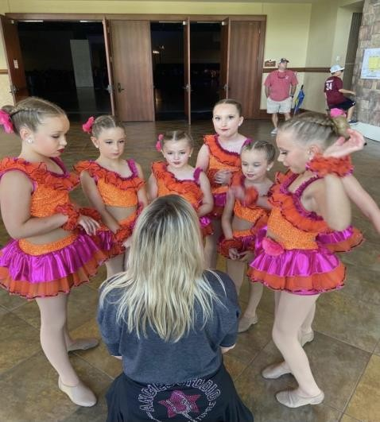

Platinum National Dance Competition (MANDATORY)
March 11th – 13th, 2022
Logan College - William Purser Center 1851 Schoettler Rd.
Chesterfield, MO 63017
FEES: (Due February 1st, 2021) Groups: $50.00 per dancer/per routine Solos: $125.00 per dance
Duo/Trios: $135.00 per entry to be divided between dancers in routine

Mark Of Excellence (MANDATORY)
April 7th – 10th, 2022
St. Charles Convention Center 1 Convention Center Plaza
St. Charles, MO 63303
FEES: (Due March 1st, 2022) Groups: $49.00 per dancer/per routine Solos: $119.00 per dance
Duo/Trios: $69.00 per dancer

Edge National Dance Competition (MANDATORY)
April 29th – May 1st, 2022 Clayton High School
1 Mark Twain Cir. Clayton, MO 63105
FEES: (Due March 25th, 2022) Groups: 52.00 per dancer/per routine Solos: $120.00 per dance
Duo/Trios: $132.00 per entry to be divided between dancers in routine

Fundraising

There will be several optional fundraising opportunities offered to help off-set the cost of competition fees. Sarah Sheppard has graciously agreed to continue to head the fundraising committee. 🙂 There will be a sign-up sheet out front if you are interested in helping with this committee. Sarah can also be reached at angiesstarzfundraising@gmail.com

Other Important Dates

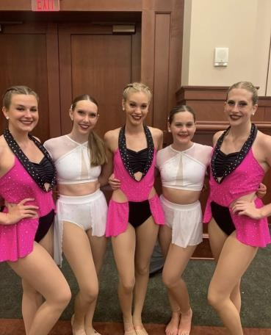

Big Sister/Little Sister Team Bonding Party (TBA)
- Sunday, October 31st Team rehearsals end by 5:00 PM for Halloween
- Sunday, November 28th NO TEAM REHEARSAL - Thanksgiving
- Sunday, December 26th & Sunday, January 2nd NO TEAM REHEARSAL – Holiday Break
- Saturday, February 19th Mandatory Dress Rehearsal Showcase Rally (Exact times and location TBA but will likely be evening hours.)
- Sunday, March 13th NO TEAM REHEARSAL – Competition weekend
- Sunday March 20th & Sunday, March 27th NO TEAM REHEARSAL - Studio Spring Break
- Sunday, April 10th NO TEAM REHEARSAL – Competition weekend
- Sunday, April 17th NO TEAM REHEARSAL – EASTER
- Sunday, May 1st NO TEAM REHEARSAL – Competition weekend (This marks the end of Team season.)

Optional Performance Opportunity
Dance the World Disney
June 20th – 24th, 2022

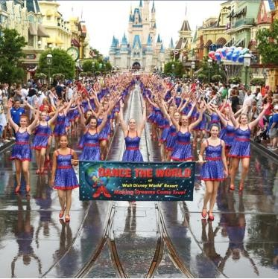

Base Package includes:

- Parade performance in Magic Kingdom® Park down Main Street U.S.A. (Ages 10-22) or 'Celebration of Dance' Showstopper at the Walt Disney World® Resort (Ages 7-9) Choreography provided by Dance the World Disney.
- Additional Stage Show Performance inside the Walt Disney World® Resort (Ages 7-22) Angie’s Studio choreography & costume
- Four (4) Night Disney Resort Accommodations Disney’s All-Star Movies Resort (additional nights can be added)
- Four (4) Day Disney Park Hopper® Ticket - Admission to Disney's Magic Kingdom® Park, Epcot®, Disney's Hollywood Studios®, and Disney's Animal Kingdom® Theme Park

Performer Bag, Complete Costume, and Ruby Red Dance Shoes
- Private transportation backstage for parade, showstopper, and rehearsal (if applicable)
- Admission to Stage Show and Showstopper Performances inside the Walt Disney World® Resort - VIP Seating Unlimited Free Access to Dance the World Performance Photos and Videos
- Trip Cancellation Protection with a full refund less $95 per person, up until 48 hours for medical, injury, or illness or 100% refund if Disney cancels the performance due to Covid and/or 100% refund for the performer and their family if the performer tests positive for Covid and is unable to attend.

Package Upgrade Options (Each package is customizable per family):

- Option to purchase Gala Celebration with your favorite Disney Characters
- Option to upgrade your Disney Park Hopper® Ticket up to 6-Days of Park Hopping
- Option to upgrade your Disney Park Hopper® Ticket to include Water Park Fun & More option
- Option to purchase Discounted Universal Studios FloridaTM and Universal’s Islands of AdventuresTM Theme Park Tickets

We are very excited about this new performance opportunity and will send out additional information, including package pricing in a separate e-mail!

Additional Potential Performance Opportunities

- Platinum Dance Convention – We will announce this information when it becomes available.
- Wentzville’s annual Holiday Parade – We will announce this information when it becomes available.
- Liberty Showcase – We will announce this information if/when it becomes available.

We are looking forward to another exciting season. Can't wait to see you there! Thank you,
Dance Team Faculty 🙂
